**MongoDB Task**

1. Find all the topics and tasks which are thought in the month of October

db.topics.aggregate([

    {

        $lookup:{

            from:"tasks",

            localField:"topicid",

            foreignField:"topicid",

            as : "topics and tasks of October"

        }

    },

    {$match: {topic_Date: {$gte:new Date("2020-10-01"),$lt: new Date("2020-10-31")}}},

])

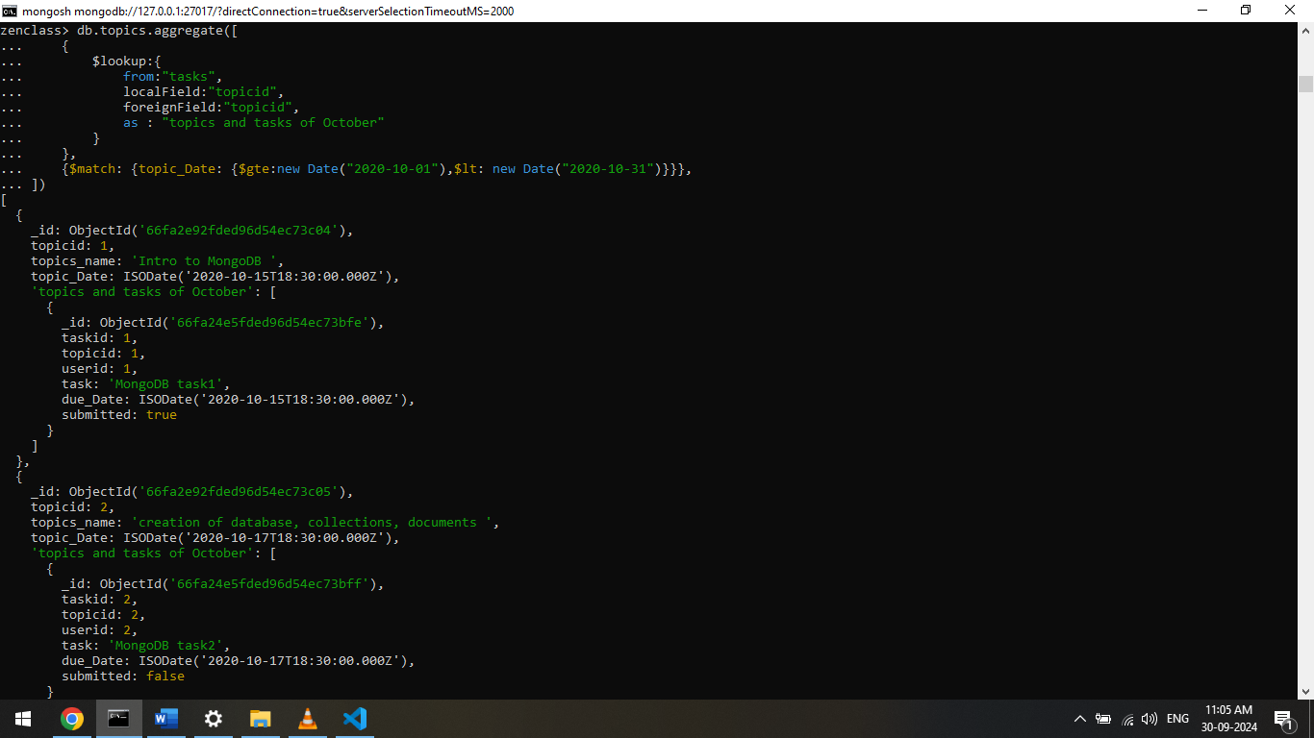

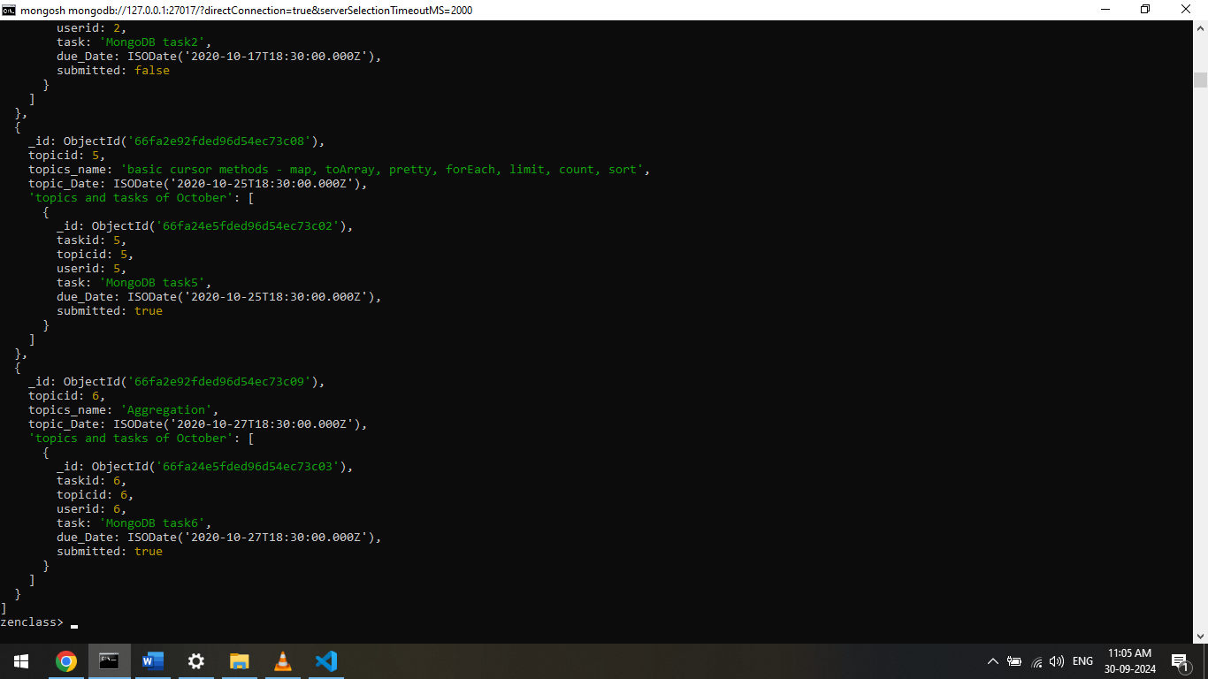

1. Find all the company drives which appeared between 15 oct-2020 and 31-oct-2020

db.companyDrives.find(

{

drive_Date: {$gte:new Date("2020-10-15"),$lt:new Date("2020-10-31")}

}

)

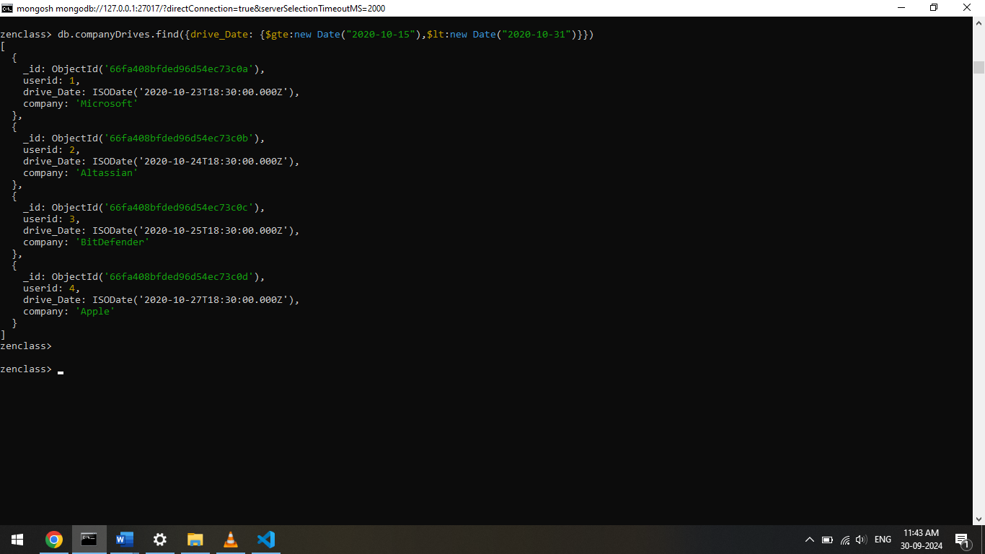

3) Find all the company drives and students who are appeared for the placement.

db.companyDrives.aggregate([

{

$lookup: {

from: "users",

localField: "userid",

foreignField: "userid",

as: "Students appeared for placement"

}

},

{

$project: {_id:0,company:1,drive_Date:1,students:"$Students appeared for placement"}

}

])

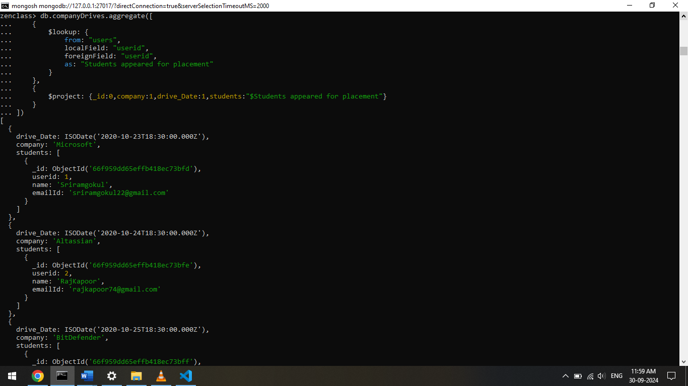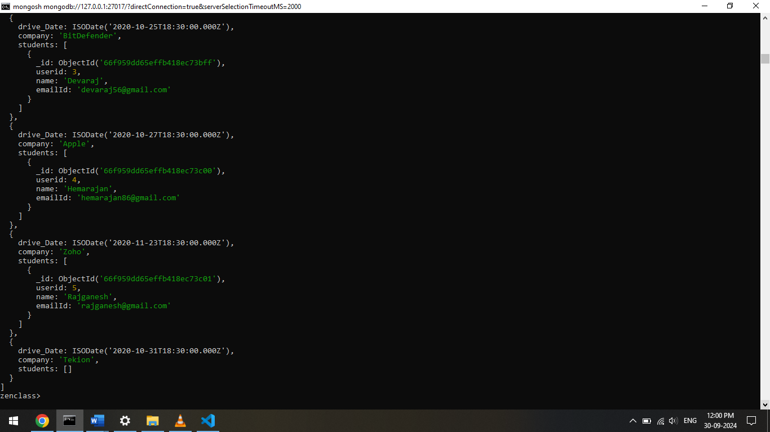

4) Find the number of problems solved by the user in codekata

db.codekata.aggregate([

{

$lookup: {

from: "users",

localField:"userid",

foreignField:"userid",

as: "users"

}

},

{

$group: {_id:{userid:"$userid",username:"$users.name"},total_problems_solved:{$sum:"$problems"}}

}

])

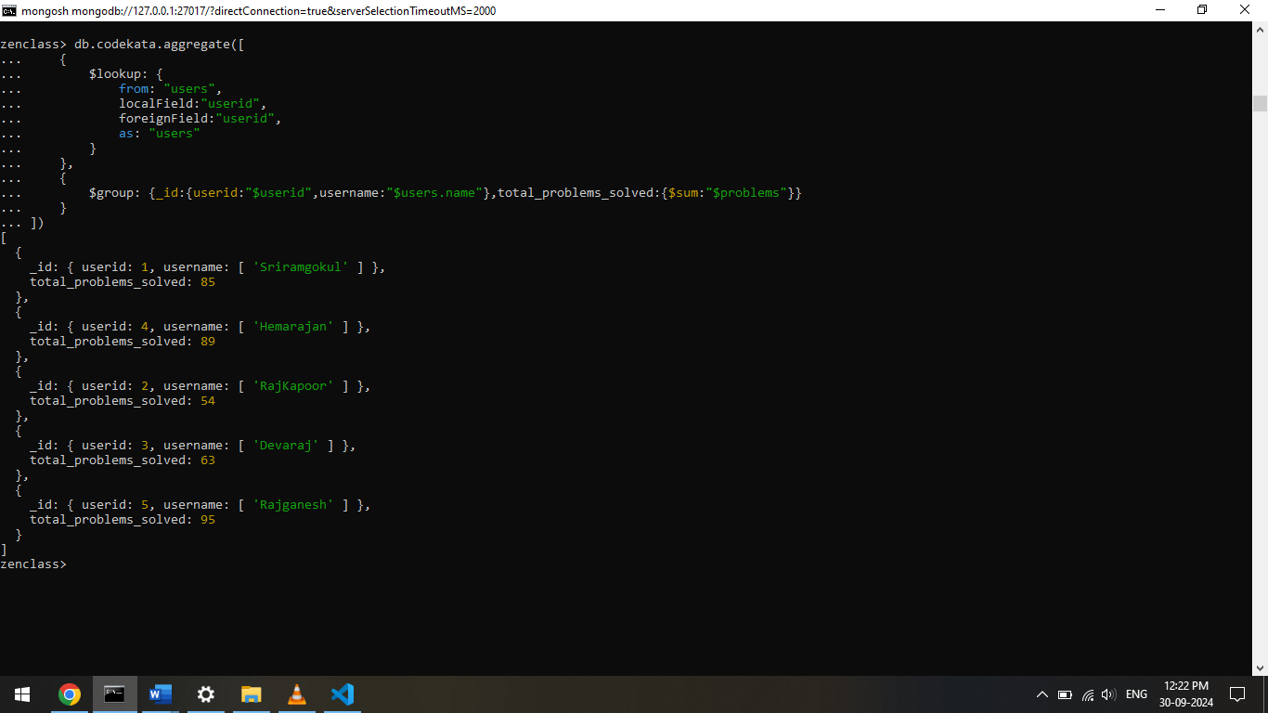

1. Find all the mentors with who has the mentee's count more than 15

db.mentors.find({mentee_count:{$gt:15}})

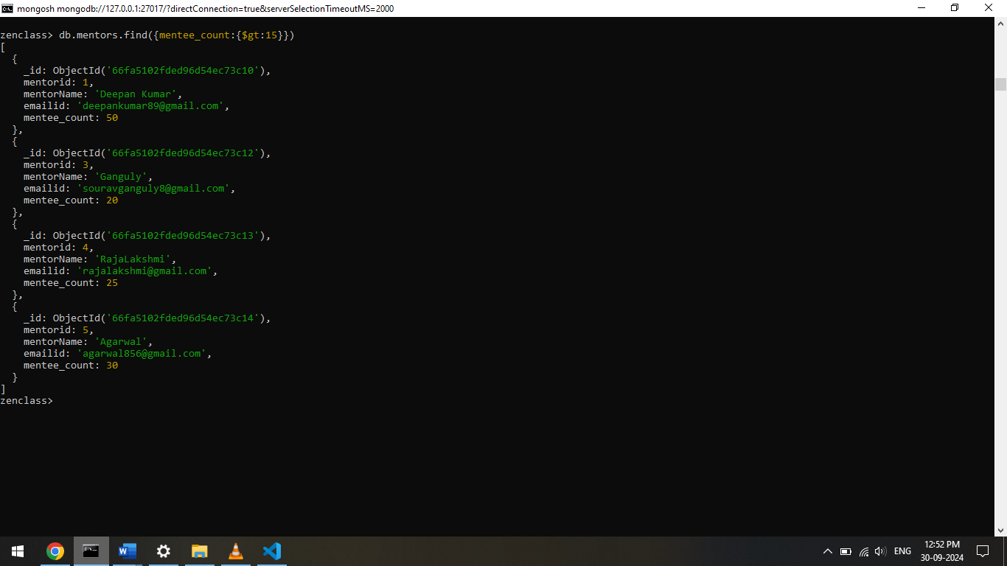

1. Find the number of users who are absent and task is not submitted  between 15 oct-2020 and 31-oct-2020

